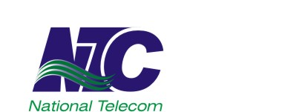 | NATIONAL TELECOMMUNICATION CORPORATION  NTC Regional Headquarters, F-5/1, Islamabad  www.ntc.net.pk
EXTENSION IN DATE
Tender No. Dir Dev (North)/ADV-02/2024-25
- Laying of OFC & UG Cable Network at PAF Base Badaber Peshawar
- Laying of OFC & UG Cable Network at PAF Base Cantt Peshawar
- Laying of OFC Cable Network at PAF Base Risalpur
d. Laying of UG cable Network at AHQ, E-9 Complex Islamabad

- With reference to our above-mentioned tender notice published in daily “Business Recorder” & daily “Express” on 20th September 2024 and uploaded on NTC & PPRA websites. The deadline of tender is further extended upto: 22nd October 2024 for all 04 x tenders. Bid submission, opening time and other terms & conditions shall remain the same. The office of Director (Development) North may be contacted for detail or any query.
Director (Development) North
Room No. 06, Ground Floor,
NTC Regional Headquarters, F-5/1, Islamabad
 051-9209293,  051-9205526

Size 5 x 2

